

**GCP – HOL -Session 6**

**Building and Testing Dockerfiles**

There’s a free service that lets you quickly spin up Docker instances through a web interface called: “Play With Docker”

1. First of all, head over to [http://play-with-docker.com](http://play-with-docker.com/) and start a new session. You need to create an account first.
2. Once your session is active click on “Add New Instance”:
3. A new instance will start with a Docker Engine ready to accept commands
4. 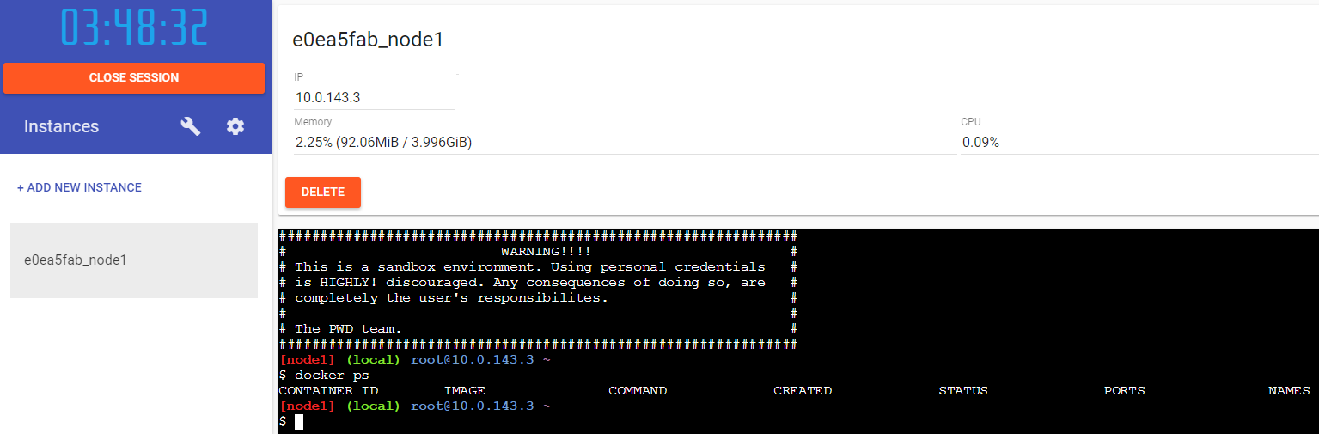
5. Next create/edit the Dockerfile. Run “vi Dockerfile”, press “i” to switch to “Insert Mode”, copy/paste the contents of our Dockerfile, press “Esc” to exit “Insert Mode”, and save+exit by typing “:x”

Build the new image using the command docker build <path>. Path refers to the directory containing the Dockerfile.

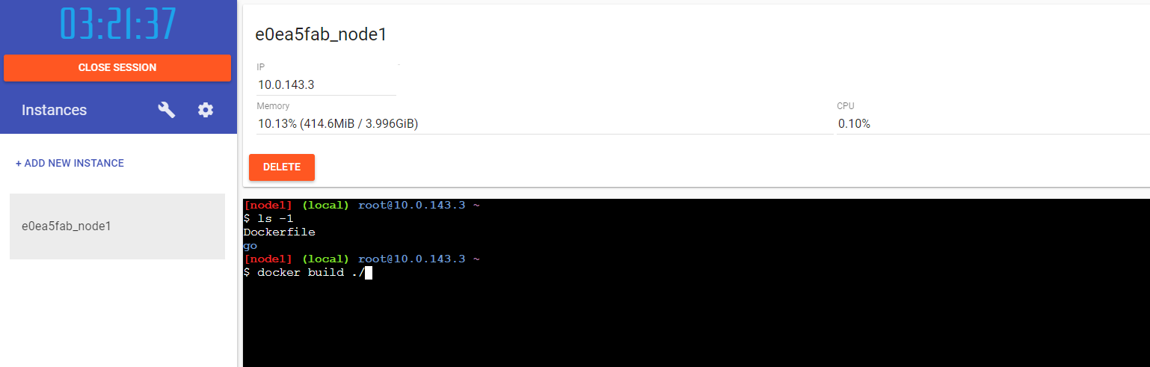

6. At the end of the process you should see the message “Successfully built <image ID>”

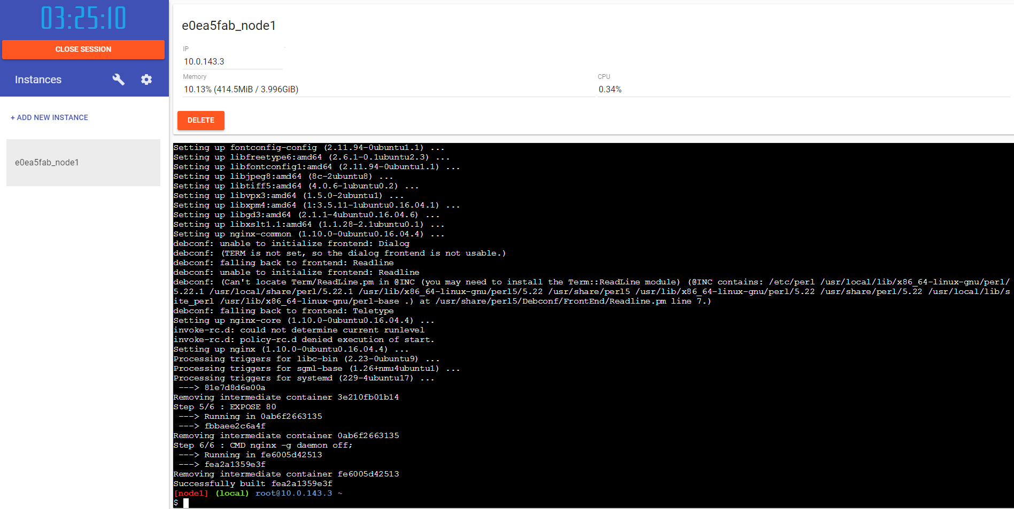7. Start the new image and test connectivity to NGINX. Run the command docker run -p 80:80 <image ID>. The option -p 80:80 exposes the Container port 80 as the Host port 80 to the world

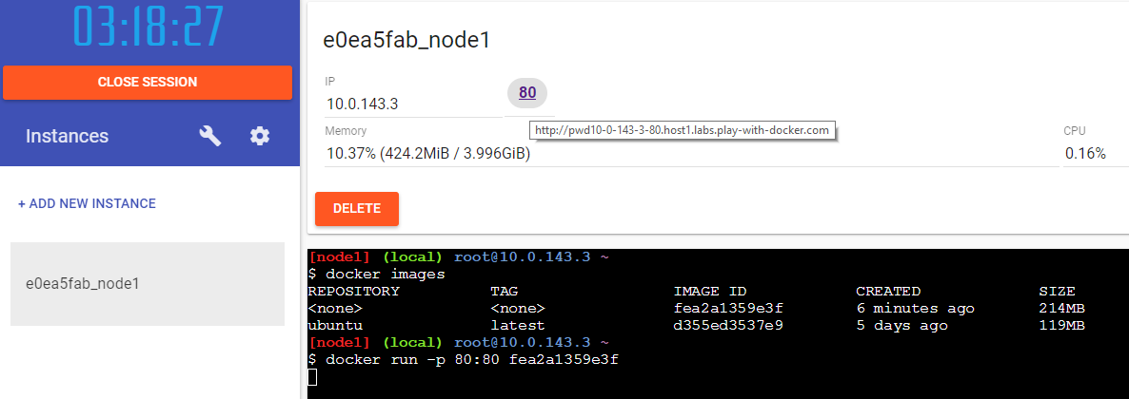8. As a result a port 80 link should have become active next to the IP. Click on it to access your NGINX service